Tin Town Tales | 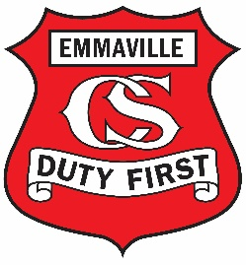
Emmaville Central School & Community News
Find us at: 20-28 Park Road Emmaville NSW 2371
Ph: 67347235 Email: emmaville-c.school@det.nsw.edu.au
Issue 7 Tuesday 16 May 2023 Term 2 Week 4

FROM THE PRINCIPAL’S DESK

Dear Parents/ Carers and community members,

Athletics carnival
Athletics carnival has been postponed until Thursday 25th May 2023. All families and community members are invited to come and share this great event with our children. The day is set to begin at 8:45-9am with the 100m sprints beginning the day. Catering will be available on the day.

Mother’s Day Stall
Thank you to the P&C for running a great stall. We hope all mums enjoyed their presents.

E safety
It is vital that we all keep our children safe when they are using electronics. The e-safety commissioner has released an updated suit of resources to assist parents and schools with this ever increasing issue. To access the site go to www.e.safety.gov.au/parents. As you can see from the screen shot below, there are lots of useful things to help us keep everyone safe. One point to note is the red square at the top right hand side of the screen, where you can report abuse.
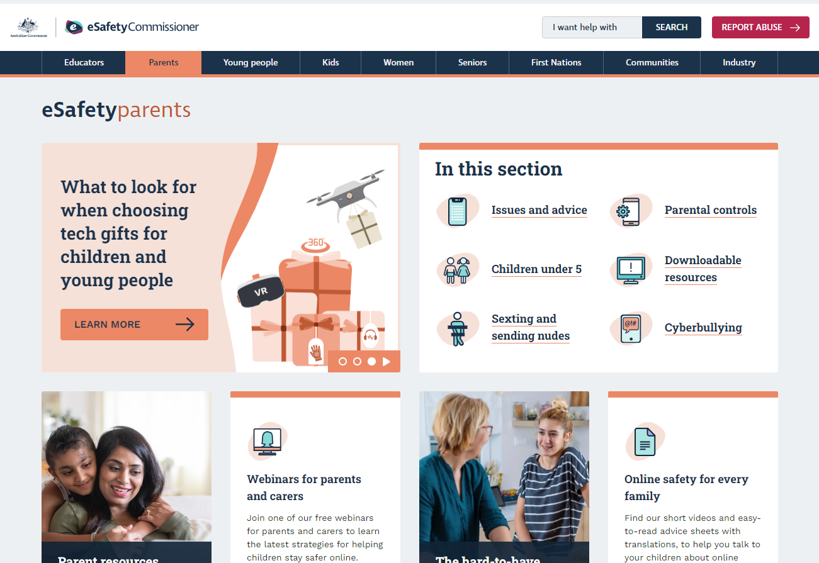

Kind regards
Mrs Gillian Davis
Principal

SECONDARY NEWS

It has been a busy fortnight, and it is shaping up to be another busy one ahead! We’ve got the Bright Girls Workshop later this week.
Great work in class
It’s always wonderful to see some of the great work that students are doing in class. Mrs Cunningham’s Science class have been learning about waves and made a ‘wave machine’ to observe energy transfers. Mrs Key’s Food Tech class experimented with different flavours and made coconut chicken cups, which were described as, “ if beautiful were a flavour, this would be it”.
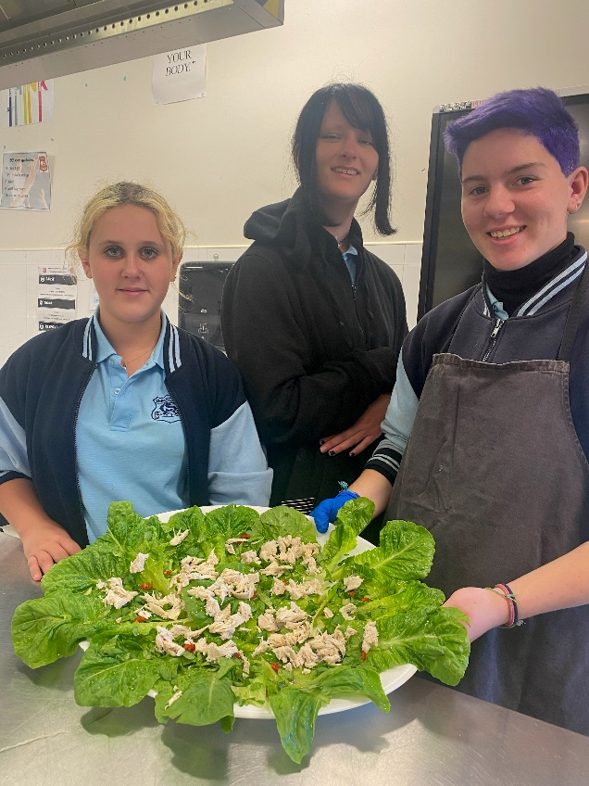
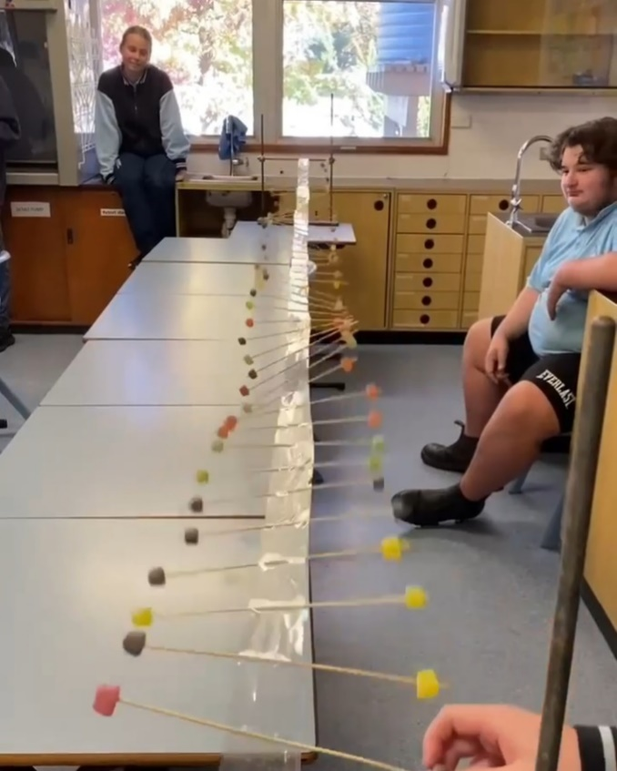
Chess Competition
Earlier this week we had a visit from The Holy Trinity Chess Team, for an inter-school chess competition. It’s great to see that students can engage with their peers from other schools to participate in events like this. Thank you to Mr Peach for coaching our chess team, and organising this experience for the students.

School uniform
It was great to see all students in their uniform for school photos. This also highlighted that students do have uniform, however on a day-to-day basis many secondary students are not wearing school uniform. Different coloured jumpers, tights and jeans do not form part of our uniform. If you need assistance purchasing uniforms for your child, please contact the school.

Best wishes for the fortnight ahead.
Miss Rebecca Grant
Head Teacher- Secondary Studies

PRIMARY NEWS

Again, the 4/5/6 students created some beautiful artworks using tone to give the illusion of looking up at the moon on a snowy evening. They also had some fun with Chrome Music Lab attempting to make their own version of ‘Twinkle, Twinkle Little Star’ using the song maker app. Some students even added beats including the drums or the triangle. The students demonstrated great persistence during this lesson.

The primary students have been enjoying a variety of new lunchtime activities including Lego and playdoh. Here are some of their interesting creations.
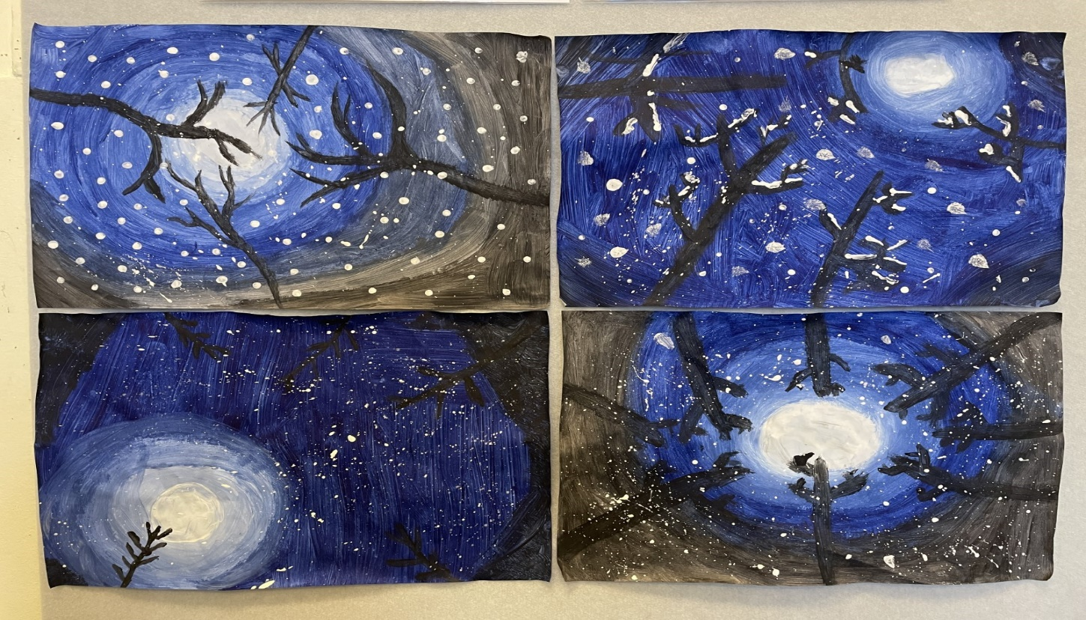

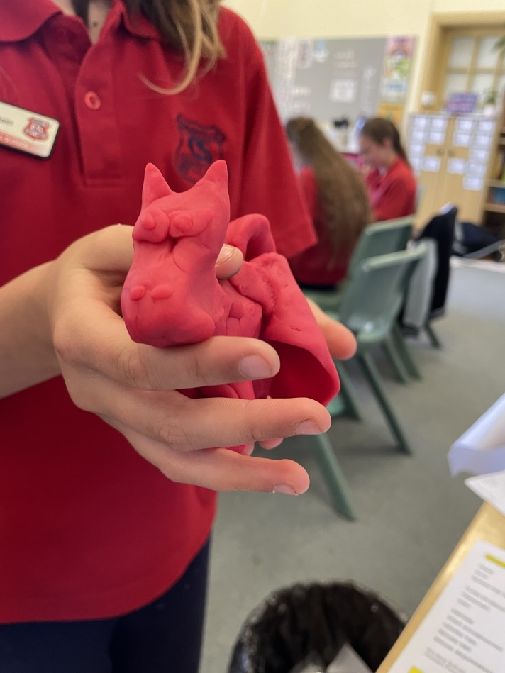

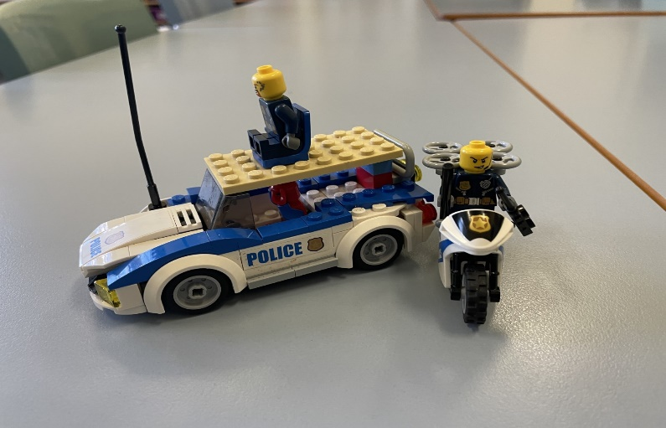

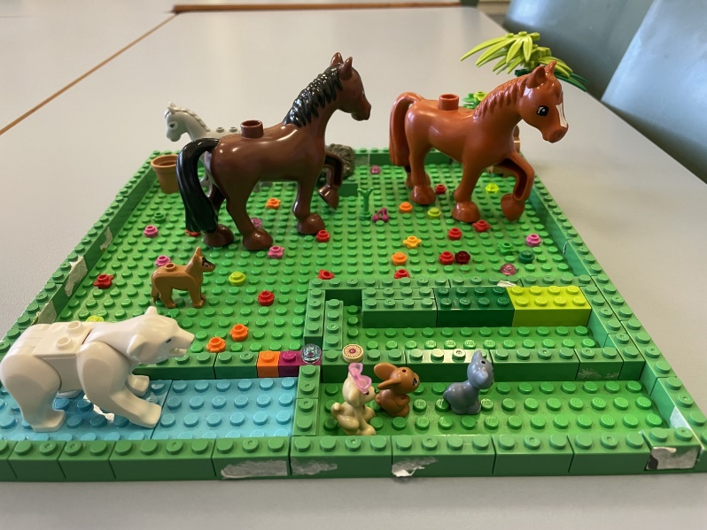
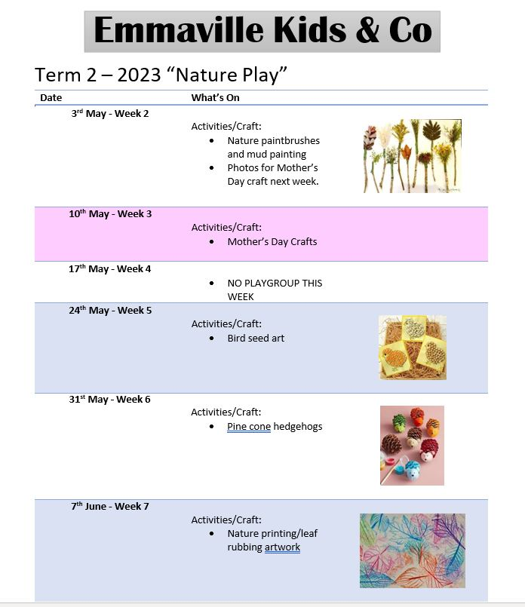

For sport in Term 2, Primary and Secondary students will be undertaking an AFL program with an accredited coach as part of the Sporting Schools program. If you are interested in registering to play junior AFL in Glen Innes, please have a read of this flyer from the Glen Innes Celts!

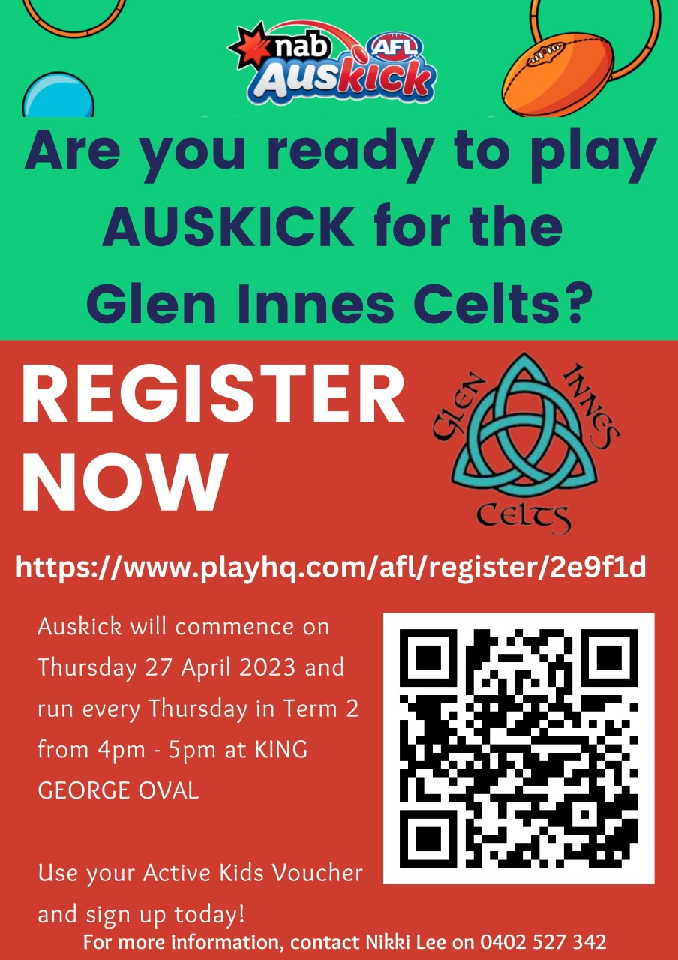

TERM 2 CALENDAR
 | Monday | Tuesday | Wednesday | Thursday | Friday
Week 4 | 15 May | 16 May | 17 May | 18 May | 19 May
 | - Week B |  | - Play Group | - Bright Girls Session
Week 5 | 22 May | 23 May | 24 May | 25 May | 26 May
 | - Week A |  | - Play Group  - Simultaneous Story Time | - Whole School Athletics Carnival
Week 6 | 29 May | 30 May | 31 May | 1 June | 2 June
 | - Week B |  | - Play Group |  | - National Walk Safely to School Day
Week 7 | 5 June | 6 June | 7 June | 8 June | 9 June
 | - Week A |  | - Play Group
Week 8 | 12 June | 13 June | 14 June | 15June | 16 June
 | - Week A |  | - Play Group
Week 9 | 19 June | 20 June | 21 June | 22 June | 23 June
 | - Week A |  | - Play Group
Week 10 | 26June | 27 June | 28 June | 29 June | 30 June
 | - Week A |  | - Play Group

We are continuing our COVID – smart measures.
While the community continues to live with COVID-19, NSW Health has advised that the unpredictable nature of the virus will continue to present a health risk to the community, especially during the winter months when other respiratory illness circulate. Accordingly, our school will continue to operate with our baseline COVID-smart measures in place throughout this term to minimise transmission while prioritising student and staff wellbeing. These includes a combination of layered safety measures such as:
- Staying home if unwell and test for COVID-19 if showing any symptoms
- Boosted day cleaning of high-touch areas in our schools

